If you would like to add a memory card (or several) to the collection of Martha’s memory cards, print this page, fill it out (Front & back if you like) & mail it back to:

Nancy Stacy
10 Northcreek Place
Walnut Creek, Ca 94598

Front
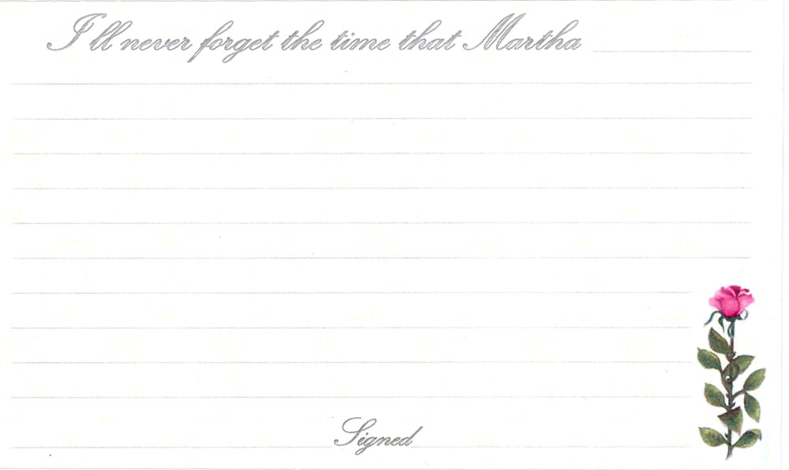

Back


